Second video

***What is MICROCONTROLLER and MICROPROCESSOR?***

MICROCONTROLLER considered as the larger unit that includes the MICROPROCESSOR (ex: ARM cortex-M4) in it.

MICROCONTROLLER defined as a MICROPROCESSOR

That attached to peripherals and modules to preform several tasks and functions.

***What is the difference between MC and FPGA?***

MC take the inputs in sequence and store it in memory and rearrange itself to respond respectively to the output.

FPGA take all the inputs and arrange itself commensurate with this input to response to output as an IC.

* Take in consideration when designing embedded system: processor speed – memory storage level- working environment- life time of the products- power consummation- cost.

Third video

***What are the basic components of the MICROCONTROLLER?***

* CPU
* sRAM “temporary memory” volatile memory that the data be erased when power is cut.
* FLASH, EEPROM “permanent memory” non volatile memory that the data doesn’t be erased when power is cut.
* BUSES “transmit data to or from CPU”.
* PERIPHERALS “modules with different tasks”.

The generation of any order in the MC is depended on the speed of clock pulse of the system.

ROM “read only memory” it’s always found at the beginning of flash memory and it’s like direction code that allow the programmer to know where to start codding.

In VONNEUMANN the buses are all connected with the same point so it takes more time to respond to any order.

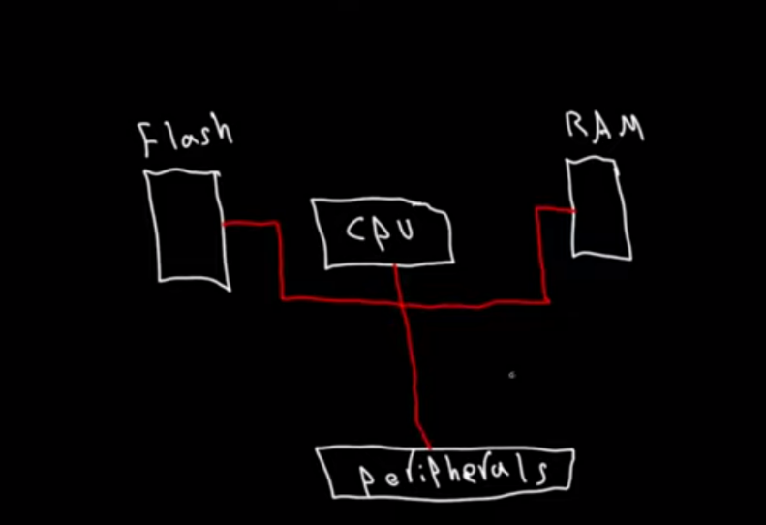

In HARVERD way the buses are not connected to the same point so it acts like its 3 times faster.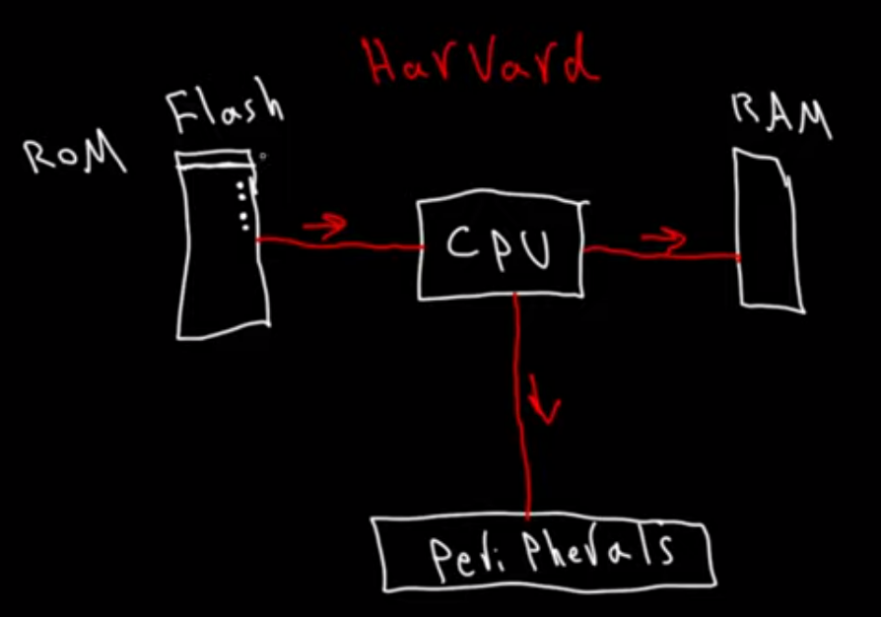

Fourth video

***What are the basic components of the MICROPROCESSOR?***

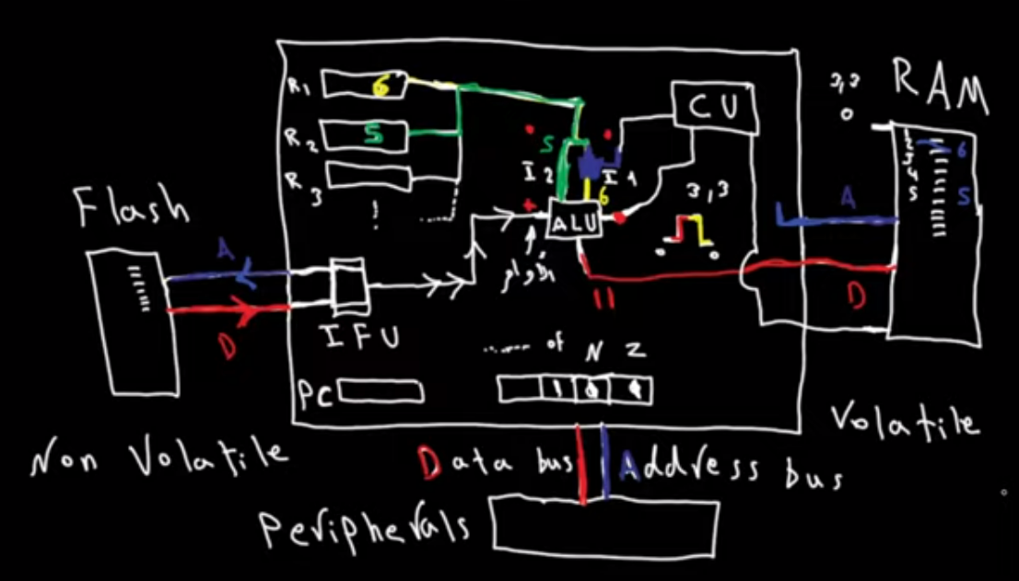

* ALU” athematic and logic operation unit” is attached to IFU that is responsible for organizing the orders that comes from flash and send it to order input in ALU.
* GENERAL REGISTERS “similar to RAM in function but it’s found inside the processer and it send the input to the ALU”
* SPECIAL REGISTER “pc – flags register “.
* Latches “is considered as agate with specific function to pass some data and block others”
* CONTROL UNIT” it gives the pulse that stimulate the latches and the ALU to generate their operations”

Fifth video

***How to convert from any numbering system to decimal system?***

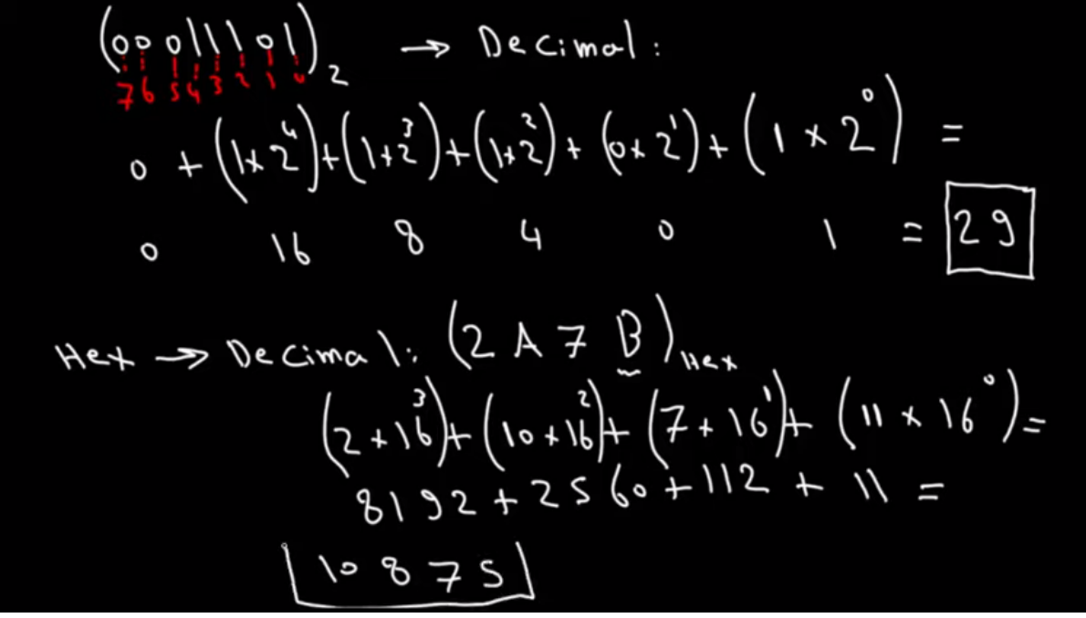

Multiply each number by the base of the system powered by its position number.

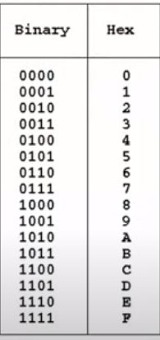

Each number in the HEXADECIMAL system is represented by 4 numbers In binary system called nibble.

The last bit in the number usually considered as the sign of the number if the number is to be signed otherwise all the bits represent the number as a whole

Seventh video

***What is the mean of transistors?***

Transistors is the combination of two words which are transport and resistors.

Transistor may be considered as a gate or a key to pass current to the circuit.

NPN transistor “N-Channel in case of MOSFET” must have a voltage difference between base” Gate” and emitter” Source” in order to pass current where base voltage must be much greater than emitter voltage also emitter” Source” is always connected to the ground.

PNP transistor “P-Channel in case of MOSFET” is the same operating concept as NPN but differs only at emitter voltage must be much greater than base voltage also emitter ”Source” is always connected to the positive terminal.

Eighth video